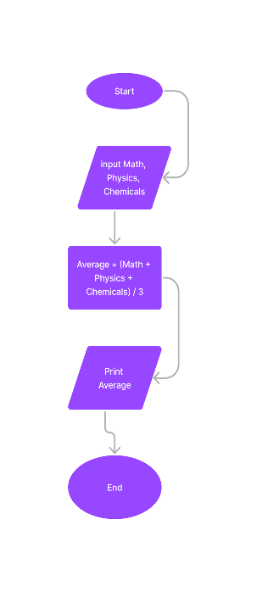begin

input a, b, c

if a > 0 then

average = (math + physic + chemical) / 3

print average

end